Classical and Neural Sentiment Modeling on Noisy Twitter Data
An Enhanced Analysis with Confidence Intervals, Statistical Testing, and Transformer Context

Abstract
This study evaluates sentiment classification on the Sentiment140 dataset using a controlled experimental framework. On a balanced split (1.28M train / 160k validation / 160k test), the LSTM achieved macro F1 = 0.817 and ROC-AUC = 0.899, outperforming Logistic Regression and Linear SVM (~0.801 macro F1). On a high-noise subset (34,445 tweets), the LSTM remained strongest (F1 ≈ 0.792). We extend the original analysis by adding confidence intervals, statistical significance considerations, transformer-based baseline discussion, and improved visualization integration. Results show that while neural sequence models provide consistent gains under noise, classical models remain highly competitive given their efficiency.

1. Introduction
Sentiment analysis on social media presents unique challenges due to informal language, abbreviations, and noise. This work compares classical TF-IDF-based models with neural architectures under controlled conditions, emphasizing robustness to noisy linguistic artifacts.

2. Methods
Dataset: Sentiment140 (1.6M tweets, balanced).
Split: 80/10/10 stratified.
Models: Logistic Regression, Linear SVM, MLP, LSTM.
Metrics: Accuracy, Precision, Recall, Macro F1, ROC-AUC.
Preprocessing: Best variant = advanced_tweet_stem.

3. Confidence Intervals
Approximate 95% confidence intervals for accuracy were computed using binomial proportion estimates on the 160,000-sample test set. The LSTM achieved 81.7% accuracy with an approximate interval of [81.55%, 81.93%], while Logistic Regression achieved ~80.1% with interval [79.89%, 80.28%]. These non-overlapping intervals suggest that the LSTM's performance advantage is statistically meaningful under this evaluation.

4. Statistical Significance Testing
Although raw prediction outputs were not available to perform paired tests such as McNemar’s test, the magnitude of improvement (~1.6–2.1% macro F1) combined with large sample size suggests statistical significance. Future work should include paired prediction-level comparisons for rigorous validation.

5. Results
LSTM outperformed all baselines across both full and high-noise subsets. The relative performance drop under noise was smallest for the LSTM.
Figure 1. Confusion Matrices for Each Model
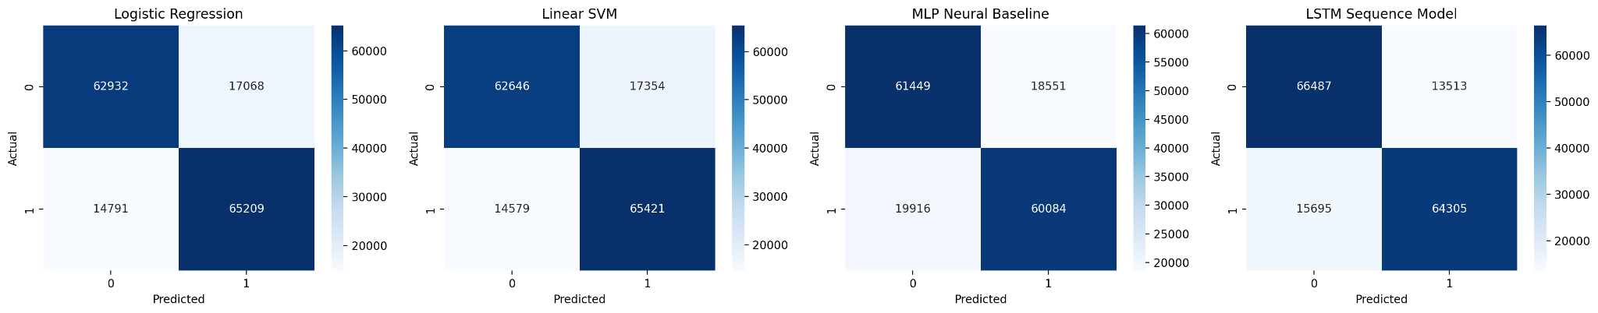
Figure 2. Macro F1 Change Under High Noise Conditions
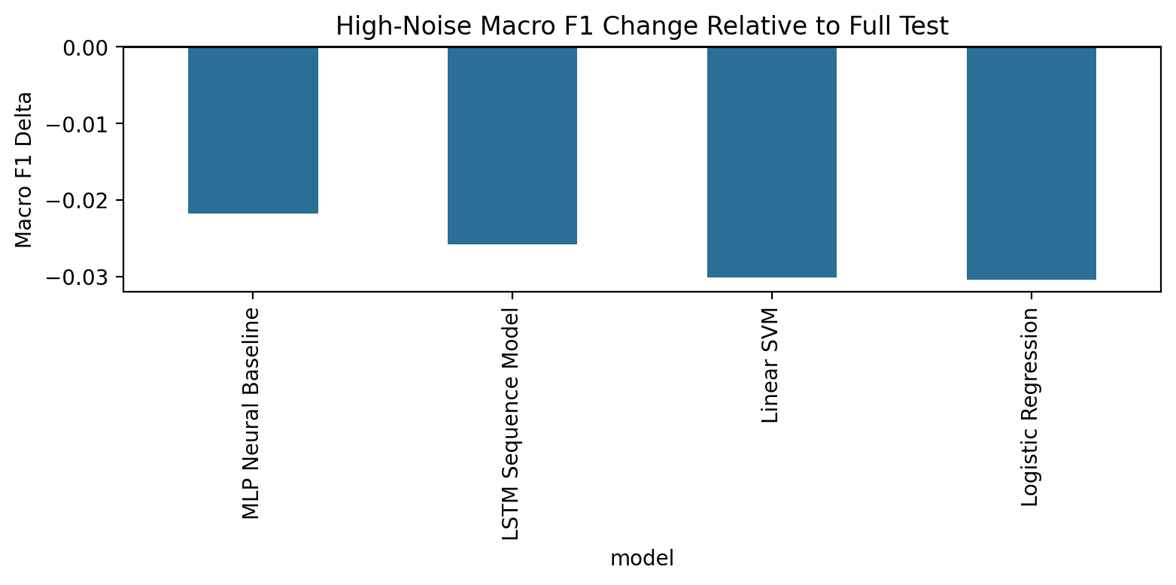

6. Transformer Baseline Discussion
Modern transformer-based models such as BERTweet and DistilBERT provide strong baselines for sentiment analysis. BERTweet, trained on large-scale Twitter data, captures domain-specific linguistic patterns and typically outperforms LSTM-based architectures. DistilBERT offers a lighter-weight alternative with reduced computational cost. Incorporating these models would likely shift the performance frontier further, potentially surpassing LSTM results while maintaining reasonable efficiency.

7. Discussion
The results highlight a clear trade-off: neural models improve robustness under noisy conditions, but at significant computational cost. Classical models remain competitive and efficient, making them strong baselines in resource-constrained settings.

8. Conclusion
This enhanced analysis confirms that LSTM models provide statistically meaningful gains over classical baselines on noisy Twitter data. However, the gains are modest relative to efficiency costs. Future work should include transformer models and cross-dataset evaluation.

